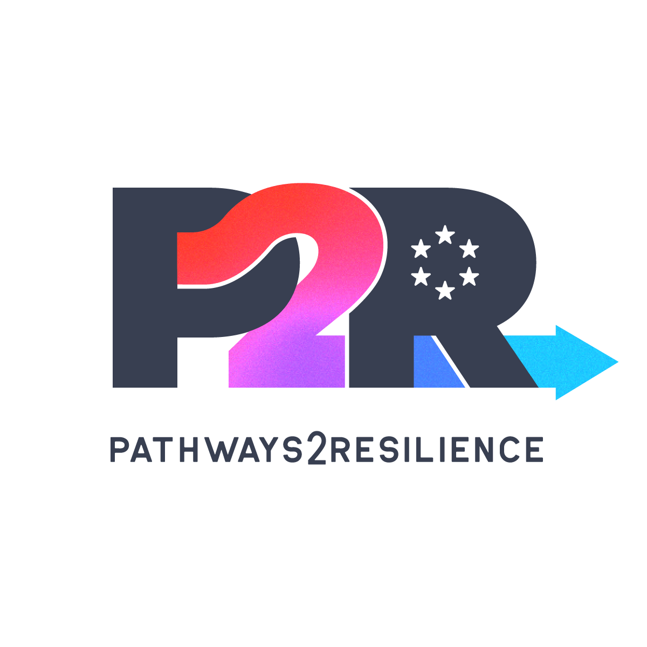

**A second** [**Pathways2Resilience**](https://www.pathways2resilience.eu/home) **funding opportunity to advance transformational adaptation in Europe**

**Call for proposals for local authorities:**

**Another opportunity to collaborate locally on climate action.**

Are you concerned about the impacts of the climate crisis in your city or region? Do you want to collaborate with local partners and benefit from the latest guidance on climate finance, and adaptation innovations? And would you like to hear from many similar cities and regions like yours? Then this call is for you!

[Pathways2Resilience](https://www.pathways2resilience.eu/home) (P2R) is an EU-funded programme that will finance and empower more than 100 regions and communities across Europe over the next 5 years, inviting them to co-design innovative visions of a climate-resilient future. Through this grant mechanism, the P2R program will support regions and communities that can develop their own transformative adaptation strategies and investment plans in a locally led and participatory way.

The Red Cross Red Crescent Climate Centre is a key partner within the P2R consortium and stresses that this project provides a valuable opportunity for the humanitarian sector to engage in climate adaptation and resilience planning, ensuring that the most vulnerable communities are appropriately considered in the process, and the voices of the most vulnerable are heard. The plans and strategies created through this process should pay special attention to inequality, bringing about change that will also benefit those most in need in our localities.

P2R has already developed a transformative adaptation framework, an 18-month Regional Resilience Journey (RRJ) that will guide regions in the creation of Climate Resilience Strategy, Climate Resilience Action Plan and a Climate Resilience Investment Plan. An online toolbox created for transformative adaptation planning will also be provided. Innovation Practice Groups will further foster knowledge exchange among diverse stakeholders, along with a peer-led monitoring programme. One-to-one support will also be delivered to at least nine regions or communities for the formulation of their adaptation pathways.

The first out of the two open calls has now been launched and applications for **funding of up to €210 000 available for another 61 regions will be open until 20 August 2025**. **The call for applicants is available to authorities from European regions and communities located in EU Member states and Horizon Associated countries.** Local and regional public authorities as well as bodies governed by public law are eligible to apply for funding, either as single beneficiaries or as coordinators of consortia. The Red Cross and Red Crescent National Societies and other CSOs can offer their partnership in this process to the local and regional authorities.

**Are you interested to take the next step with your local counterparts? Then reach out to your local government and tell them all about this opportunity that you can jointly take forward with them and other CSOs, Private Sector and community groups. Please find here the information to the second call of Pathways to Resilience:** [**https://www.pathways2resilience.eu/second-open-call**](https://www.pathways2resilience.eu/second-open-call)**.**